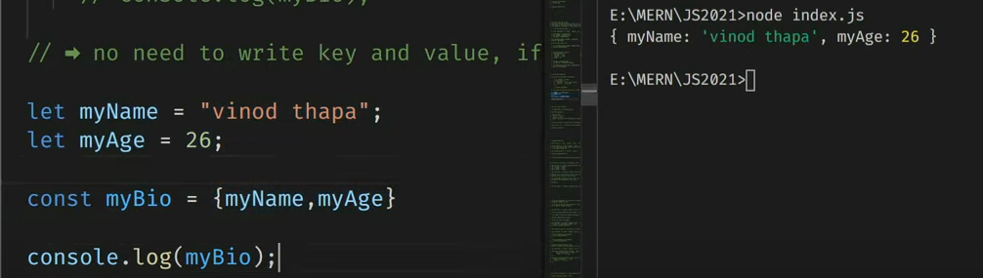For in -> returns index

For of -> returns elements

Foreach -> break and continue not acceptable, it returns undefined because it edits original array

Searching and filter in an array:

Indexof()

How to sort and and compare an array

Array CRUD

Create: **push()**

Push method returns new length of an array.

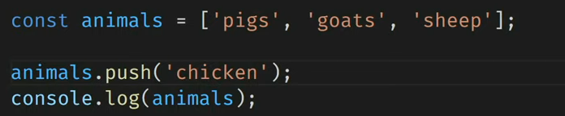

**Unshift():** adds one or more elements to the beginning of an array and returns new length of an array.

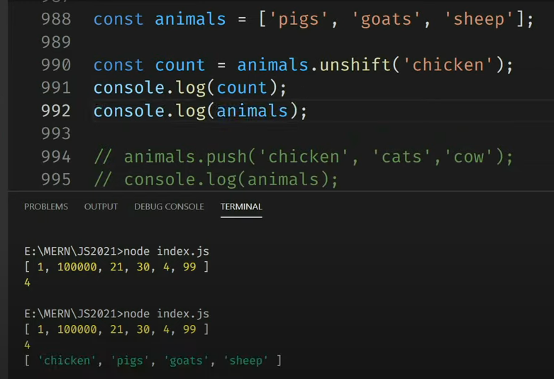

**Pop**(): removes the last element and returns that element. It changes the length of an array.

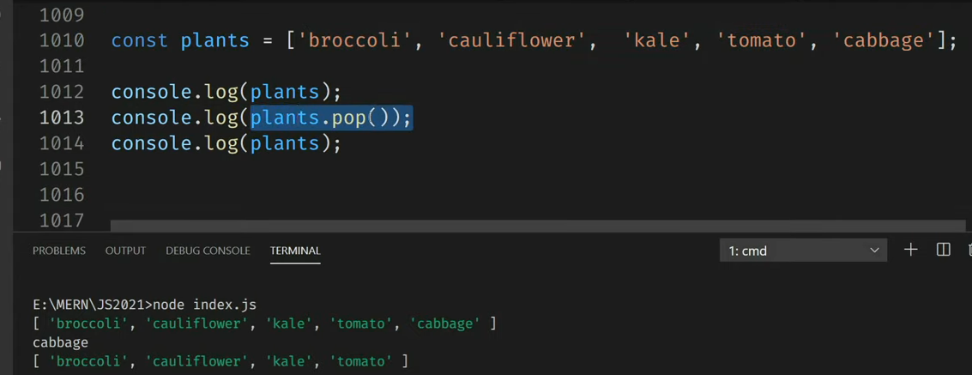

**Shift**():

It removes the first element and returns that removed element.

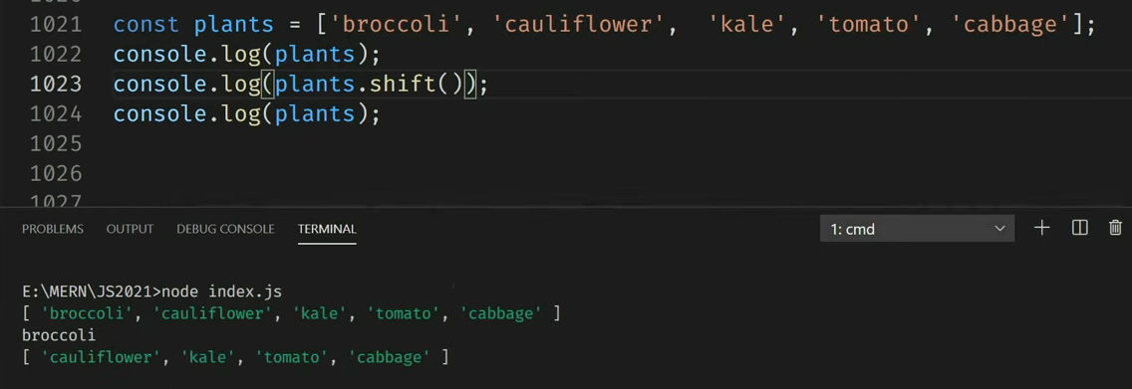

**Splice Method**: it is used for deleting. It returns deleted element.

Add dec at the end of the array

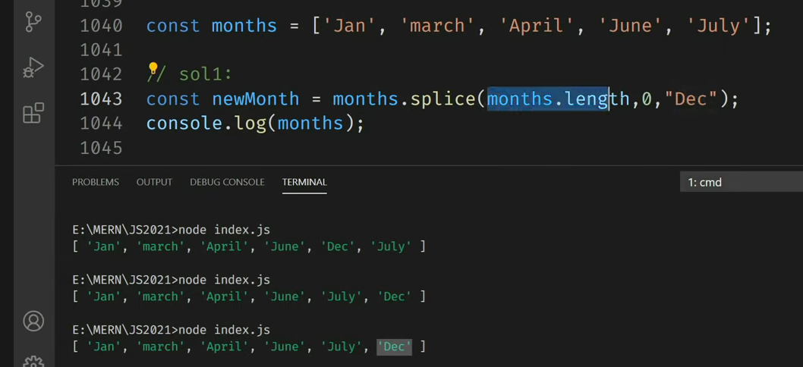

Update:

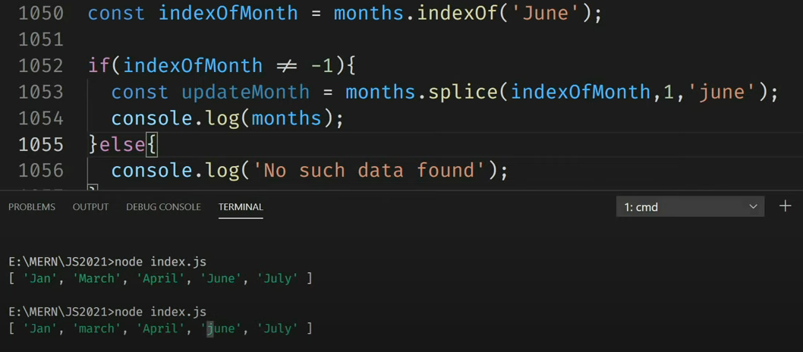

Delete

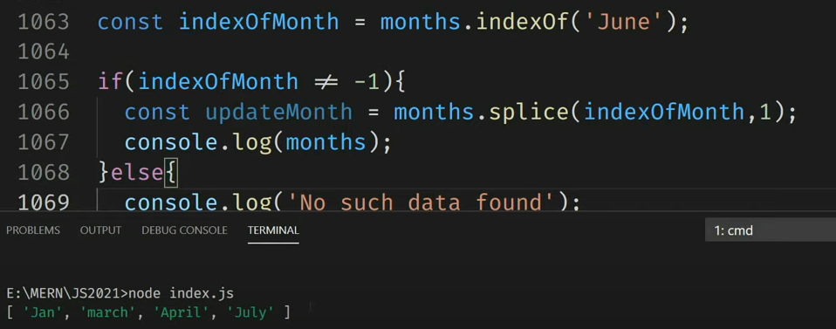

Delete using infinity:

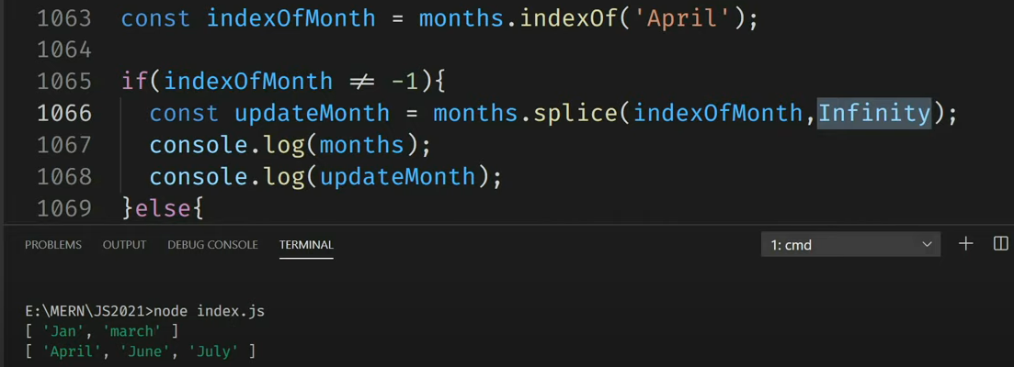

**Map Method**: It returns a new array containing the results of calling a function on every element in this array. It returns the new array without mutating the original array.

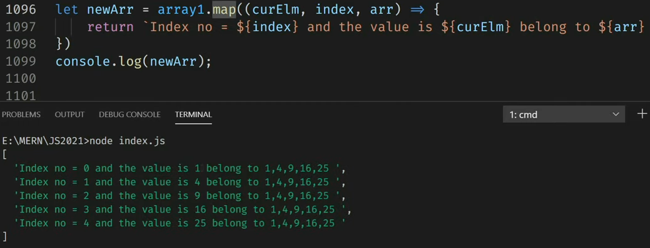

**Filter method**:

**Reduce method**: it flattens an array which means it converts the 3d or 2d array into a single dimension array. It takes four arguments: accumulator, current value, current index, source array. Don’t use reduce method to flatten an array.

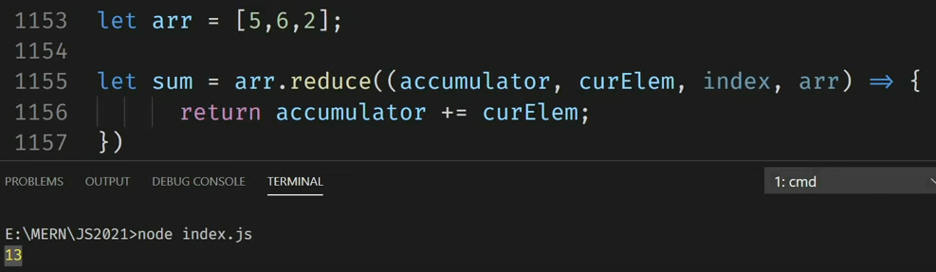

**Strings**:

String() constructor gives result in array.

Escape characters: \\ “” ‘’

”we are so called \“Vikings\” from the north.”

**indexOf():** returns -1 is there are no any searched data

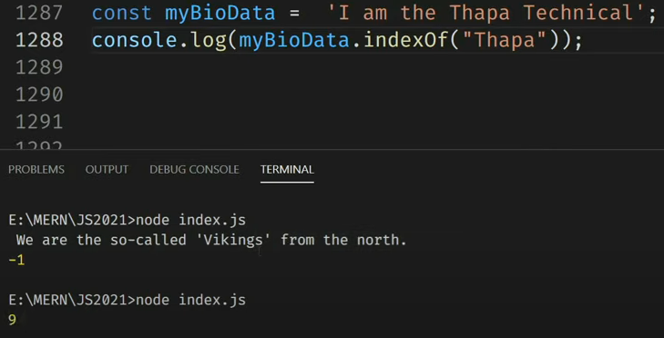

**lastIndexOf():** searches from the backwards.

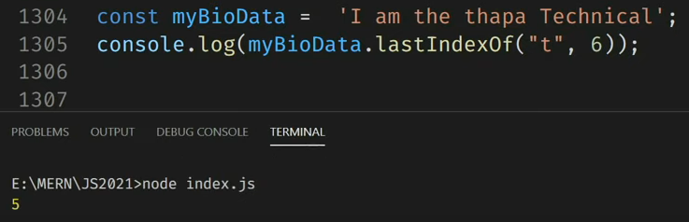

**Search():**

It searches a string for a specified value and returns the position of the match. It cannot take second start position as an argument.

**Extracting a string parts**:

Three methods: slice(start, end), substring(start, end), substr(start, length).

**Slice Method**:

It extracts a part of a string and returns the extracted part in a new string.

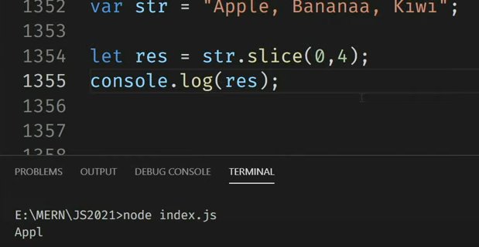

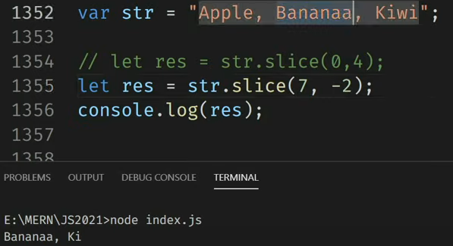

**Substring**():

It cannot accept negative index.

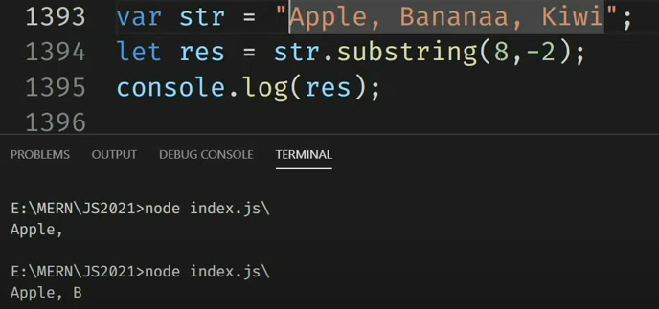

**Substr**():

The second parameter specifies the length of the extracted part.

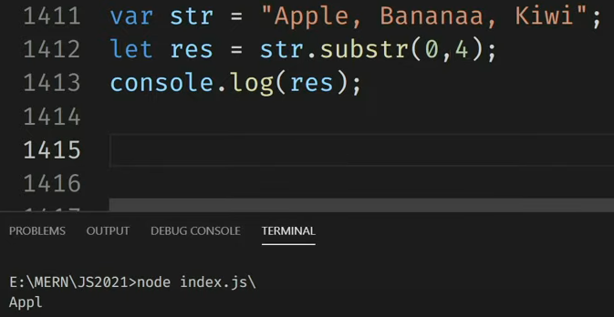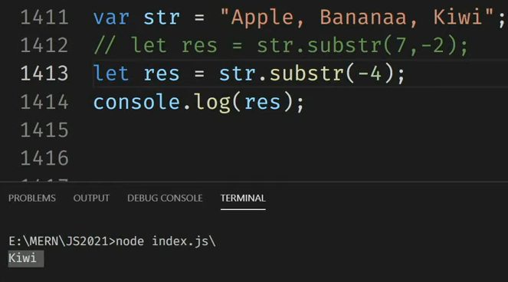

**Replacing string content:**

**Replace():**

It replaces a specified value with another value in a string. It does not change a string but returns a new string. It replaces only the first match. It is case sensitive.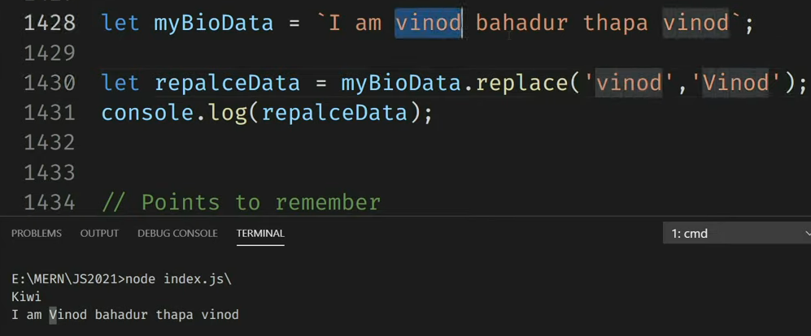

**Extracting string characters:**

3 methods: charAt(position), charCodeAt(positon), Property Access[]

**charAt**():

it returns a character at a specified index in a string.

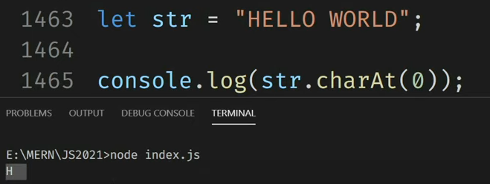

**charCodeAt**():

it returns the Unicode of the character at a specified index in a string. It returns a UTF-16 code, and integer between 65535.

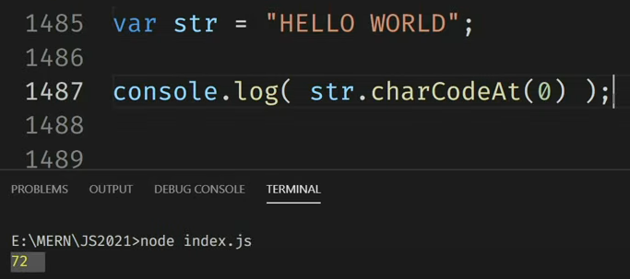

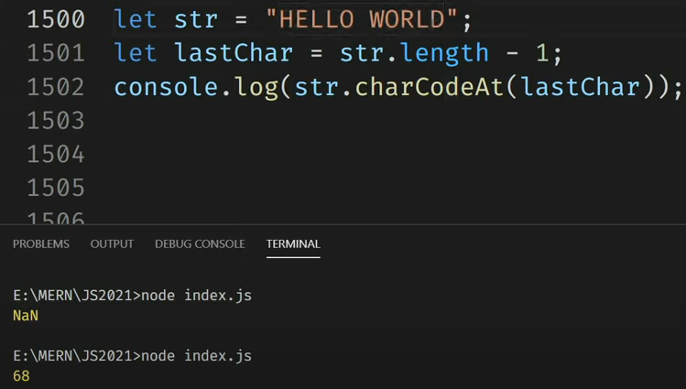

**Property Access:**

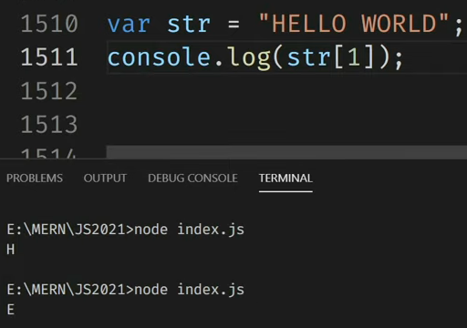

**Uppercase and lowercase method**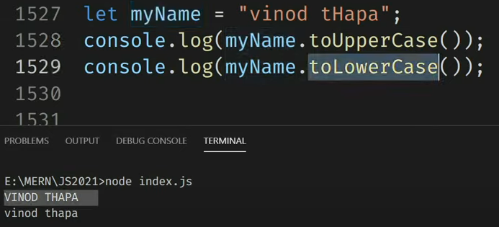

**Concat():**

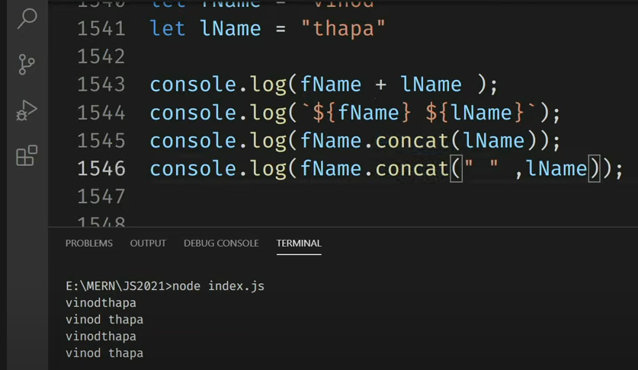

**Trim**(): it removes whitepace from both start and end of a string.

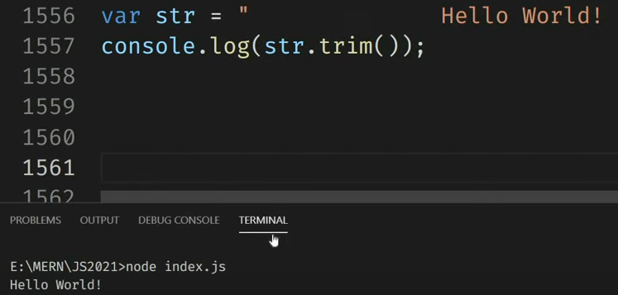

**Split**(): to convert a string into an array.

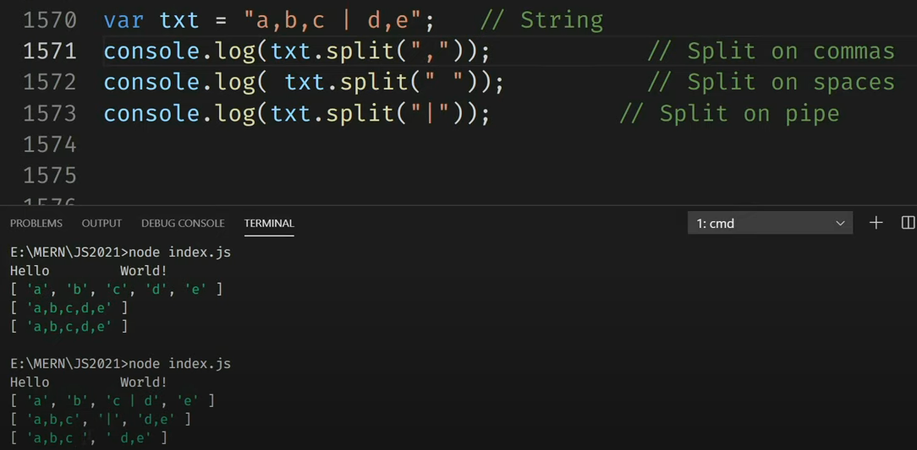

**Date and Time**

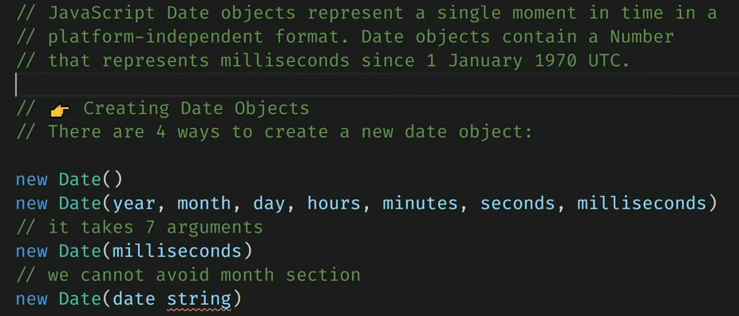

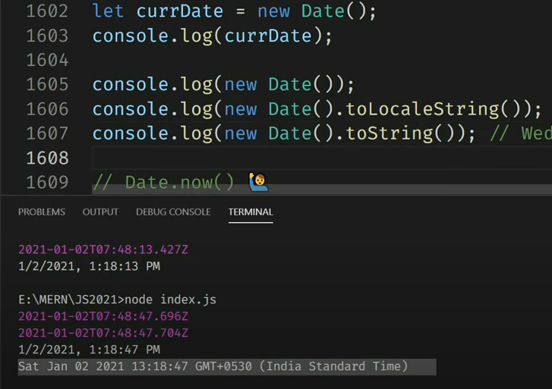

Date.now():

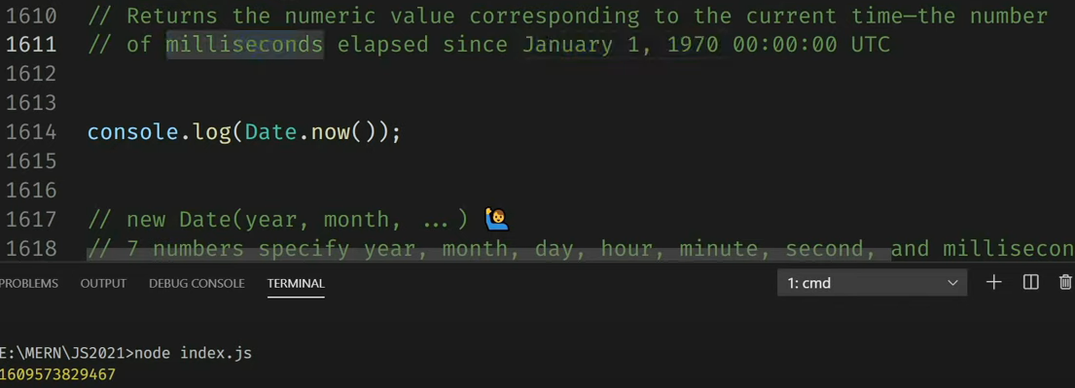

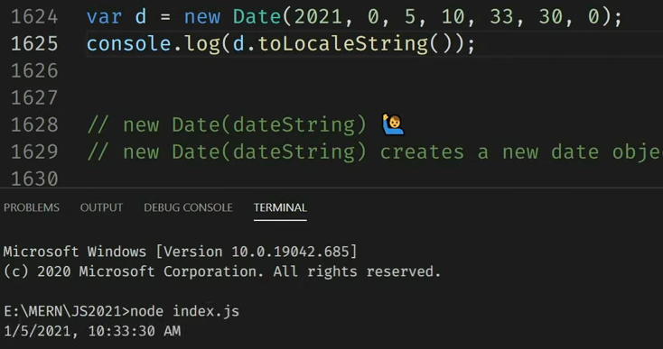

Get date:

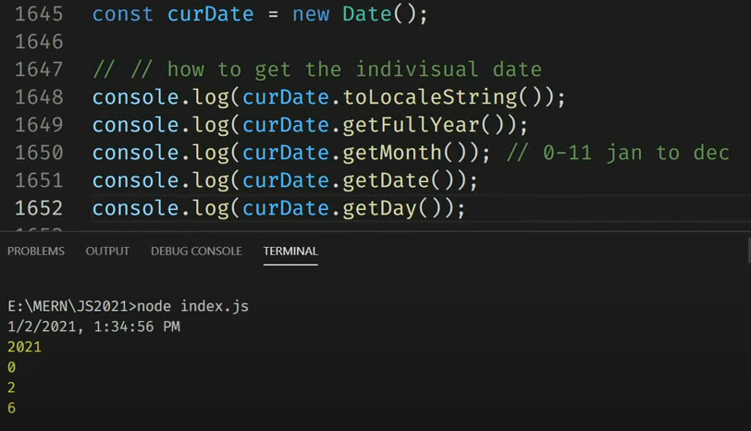

Set date:

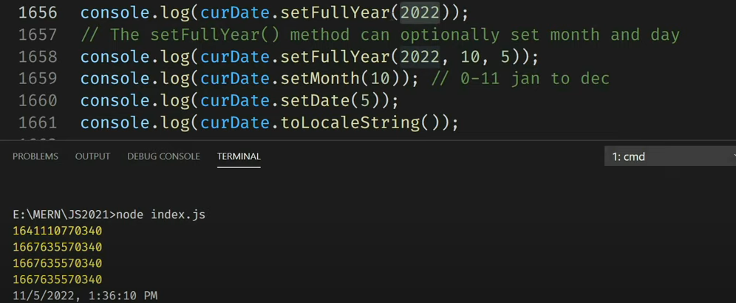

Time:

Get time:

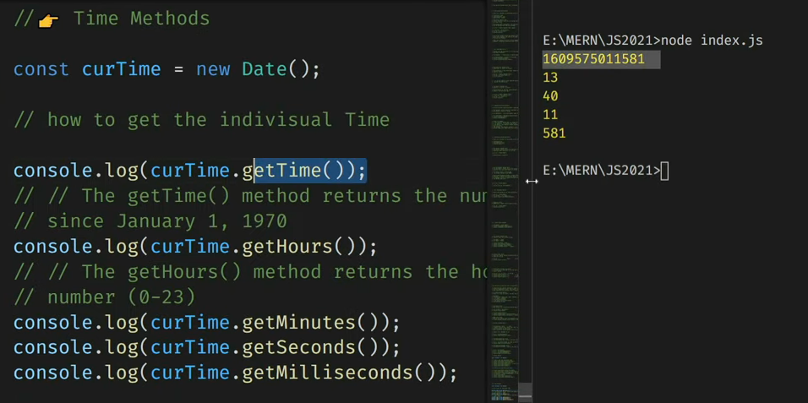

Set time:

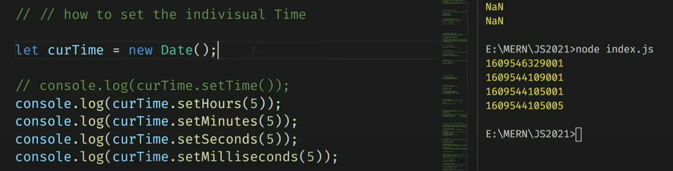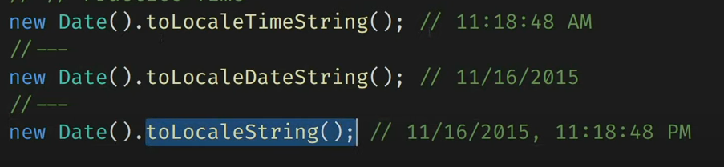

**Math Objects:**

Math.PI()

Math.round()

Math.pow(x,y)

Math.sqrt(x)

Math.abs(x): returns the absolute (positive) value of x

Math.ceil(x)

Math.floor()

Math.min()

Math.max()

Math.random(): returns random number between 0 and 1

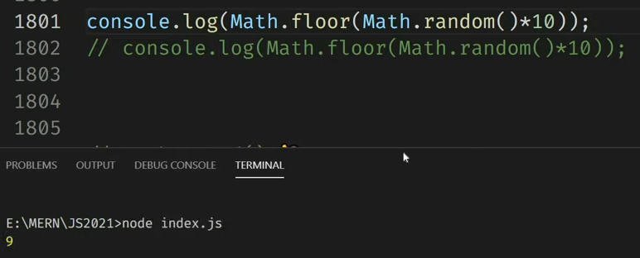

Math..trunc(): it returns the integer part of a number.

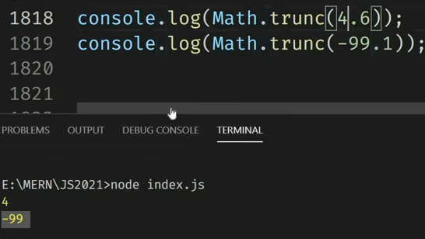

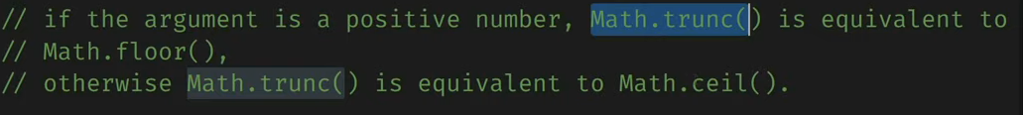

**DOM**

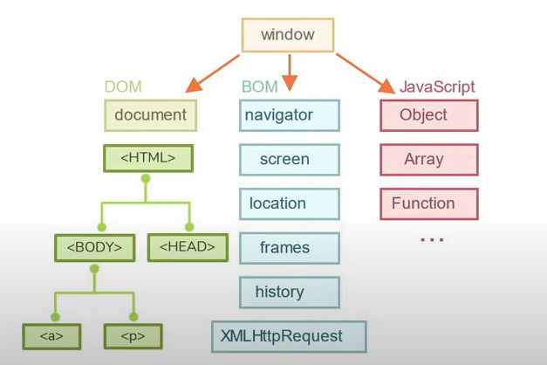

Window.history.back()

Document.body.parentNode

Document.body.childern, document.body.firstchild, document.firstElementChild

Document.body.hasChildNodes() ->. True/false

Document.queryselector(‘.child’)

Document.body.nextSibling

Document.body.previousSibling

Document.body.previousElementSibling

Document.body.nextSibling

Document.body.nextElementSibling

Search and reference:

Search:

Document.getElementById(‘heading’).innerHTML = “welcome”;

Document.getElementsByClassName(‘heading’);

Document.getElementsByTagName(‘p);

Document.getElementsByName(‘gender’);



Document.querySelector(‘#gender’).innerHTML = “welcome”;

Document.querySelectorAll(‘#gender’).innerHTML = “welcome”;

Reference:



**Events**:

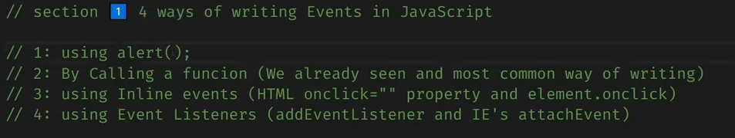

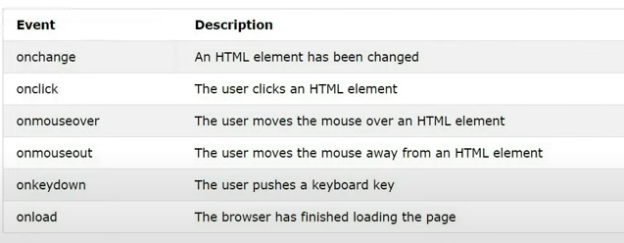

1. Alert():



1. By calling a function:



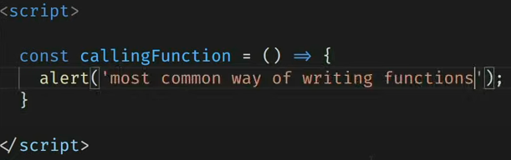

1. By using a reference: in this function is overwritten.

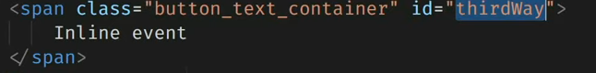

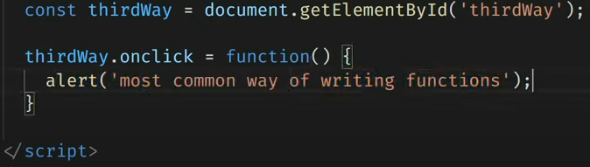

1. Event listener: same event can be called multiple times.

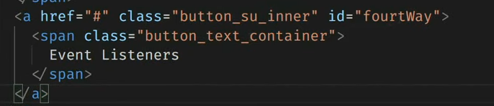

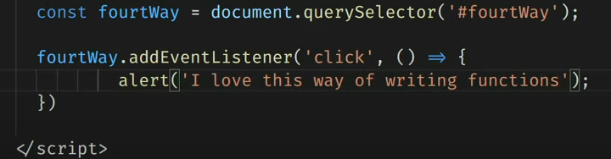

Event Objects:

1. Mouse Event:

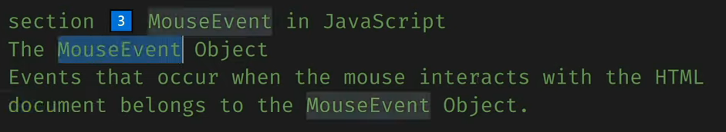

Onmousedown, onmouseup:

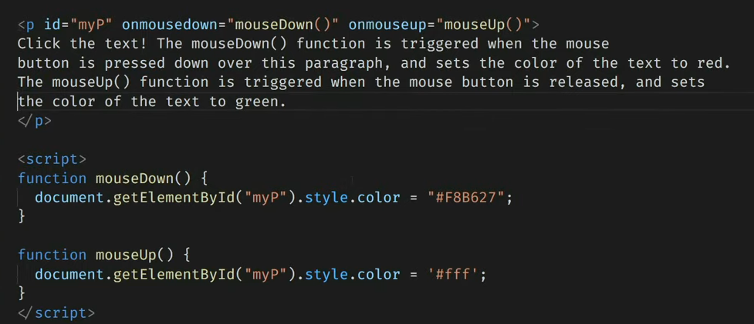

Mouseenter, mouseleave:

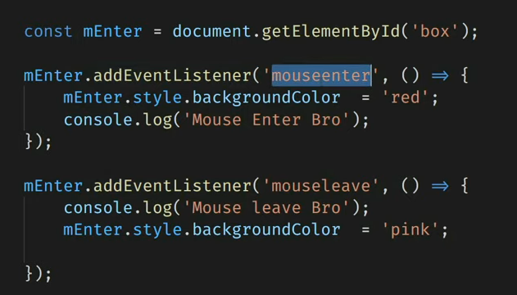

1. Keyboard event:

Onkeypress, onkeydown, onkeyup:

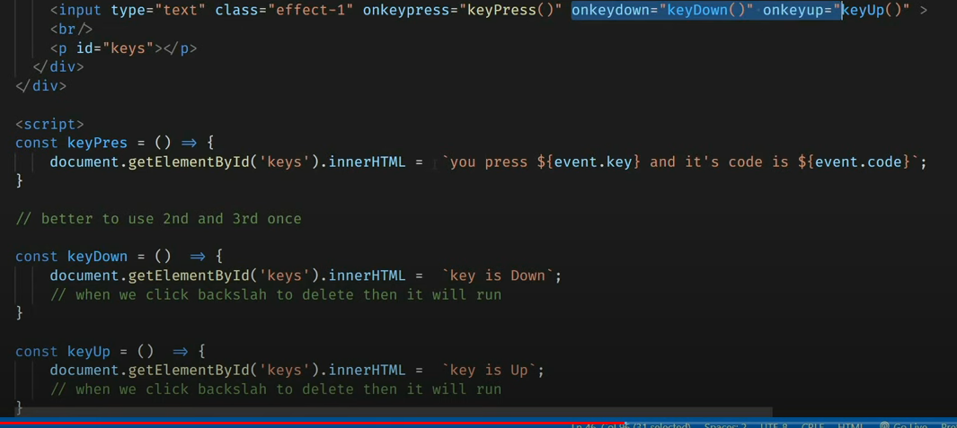

1. **Input events:**

**Onchange**:

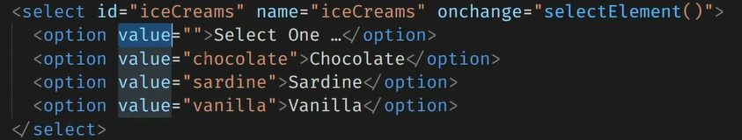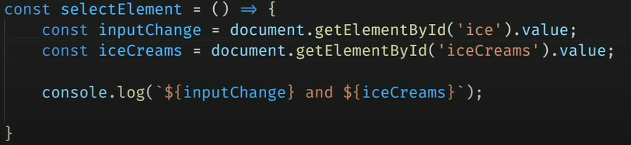

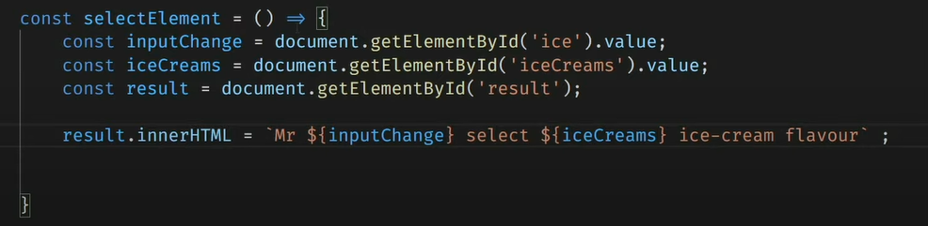

Onchange using reference:

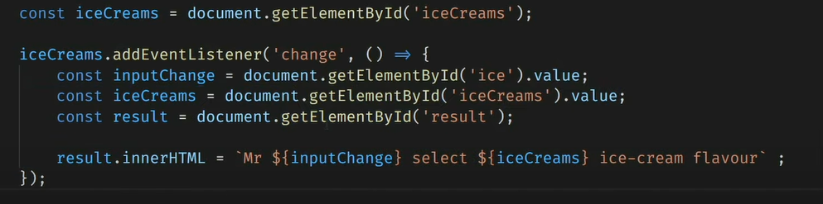

Onclick and addEventListener:

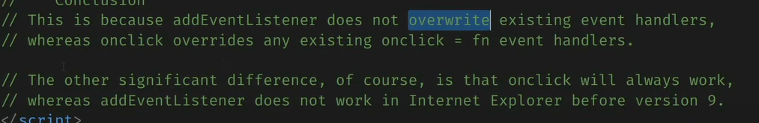

**Timing based events**:

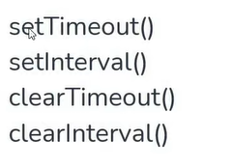

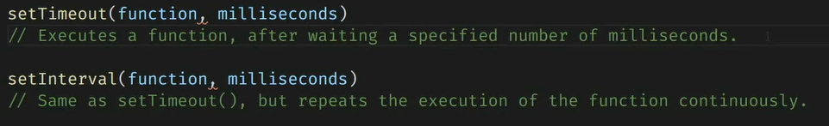

**setTimeout**():

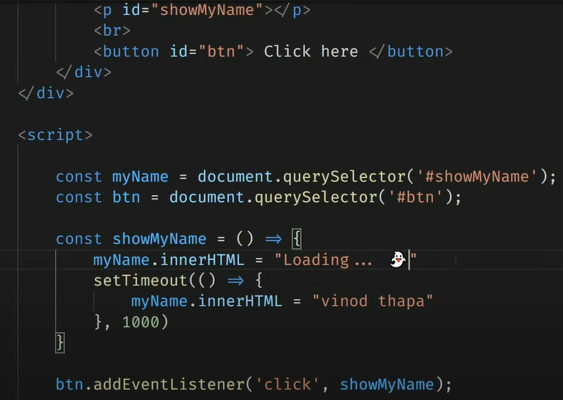

**clearTimeout**(): to stop

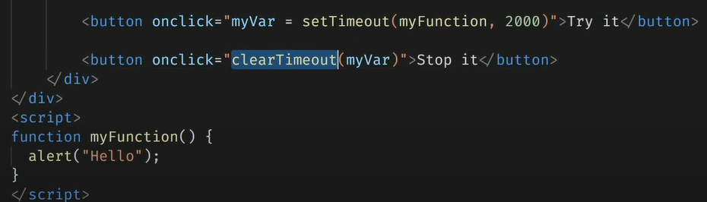

**setInterval**():

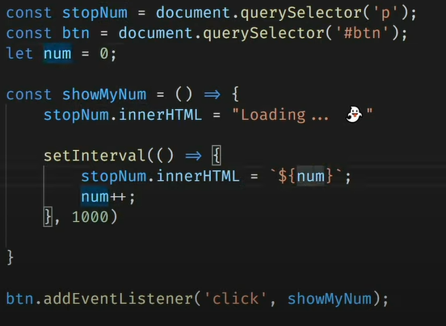

**clearInterval**():

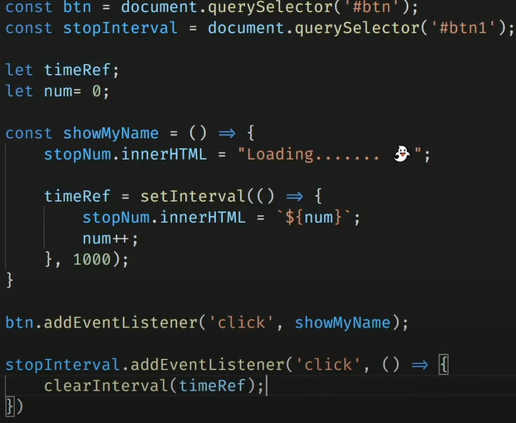

**Object oriented programming in JavaScript:**

Object literals: it is a key: value pair data structure. It stores variables and functions together in one container which is an object.

Create object:

1st way:

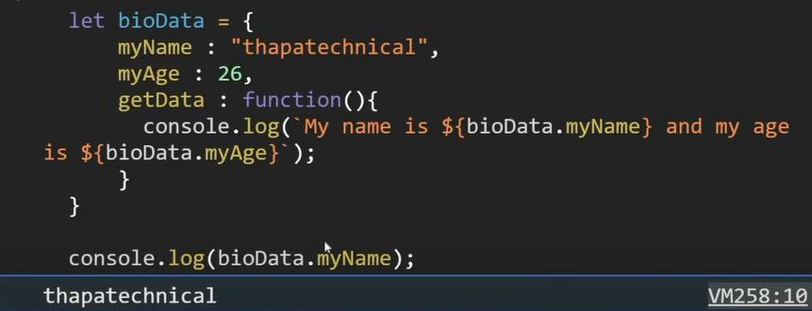

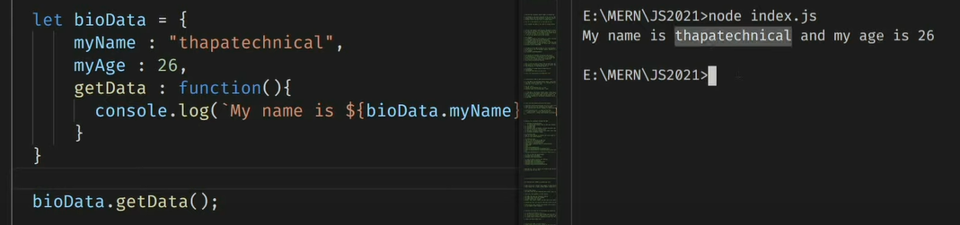

2nd way:

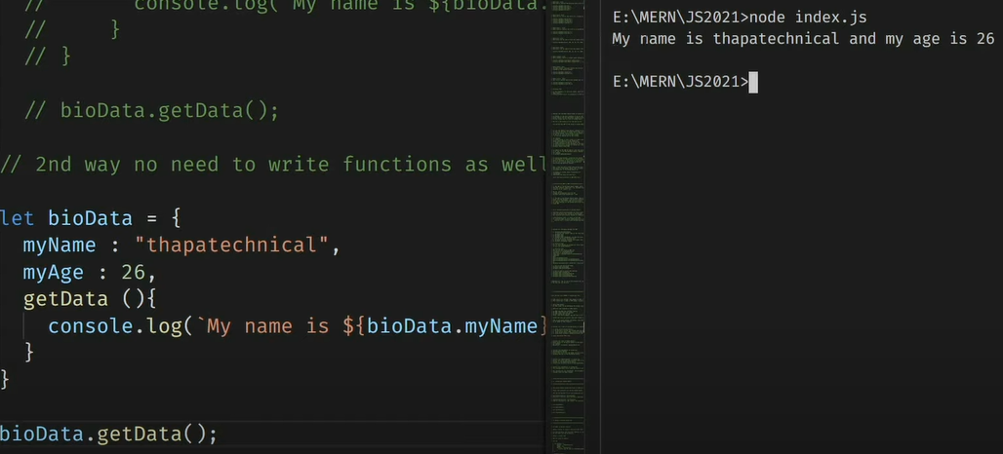

Object as a value inside an object:

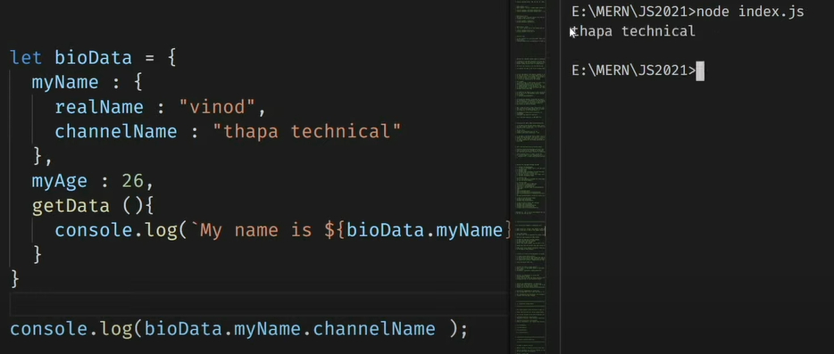

**This Object:**

It contains the current context. This will not work in fat arrow function.

**Array destructuring:**

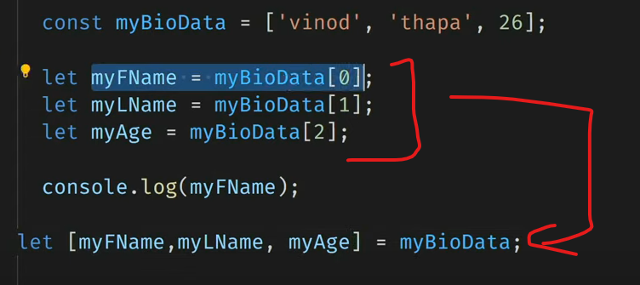

Object destructuring:

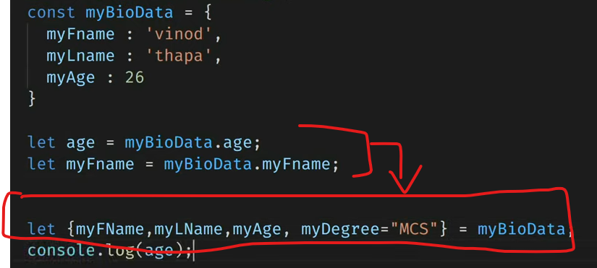

Object properties:

Dynamic properties:

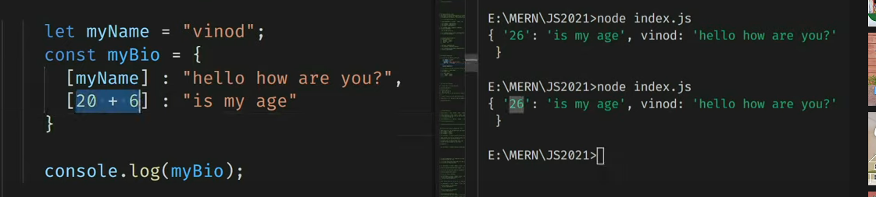

No need to write key and value if both are same.



Spread Operator:

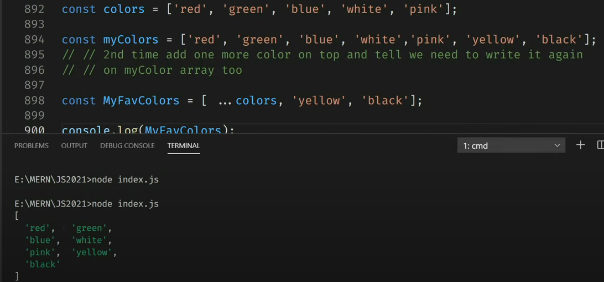

**Es7 features:**

1. **Array include:**

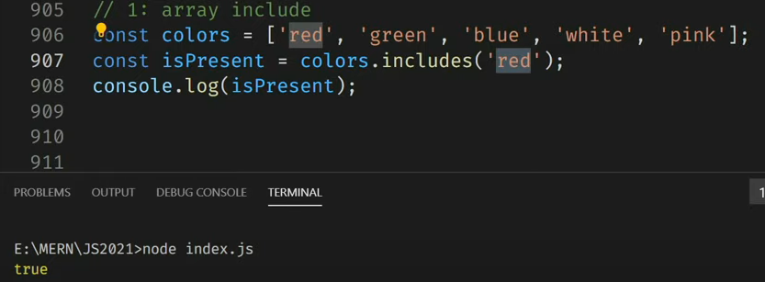

1. Exponential operator:

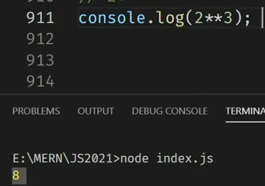

**Es8:**

1. Async await
2. **String padding**: padStart(), padEnd().

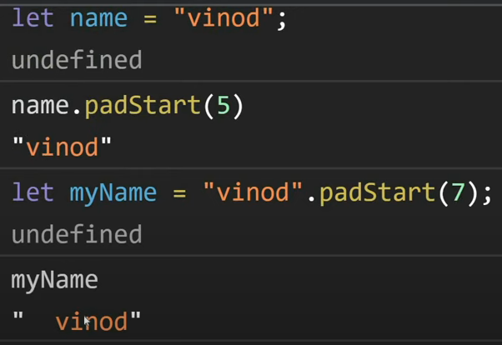

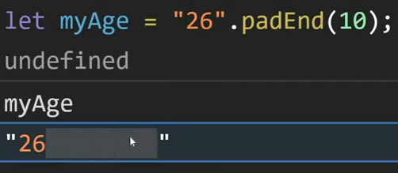

3.object.values():

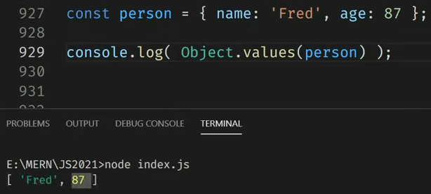

1. **Object.entries():**

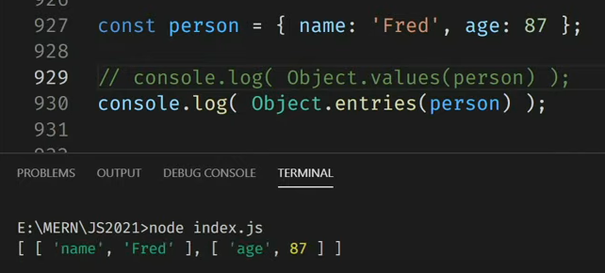

**Es9:**

Object spread operator:

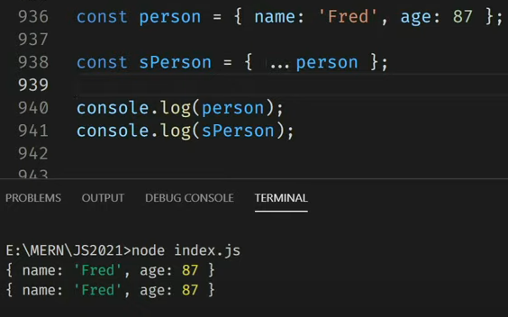

**Es10**:

1. Flat:

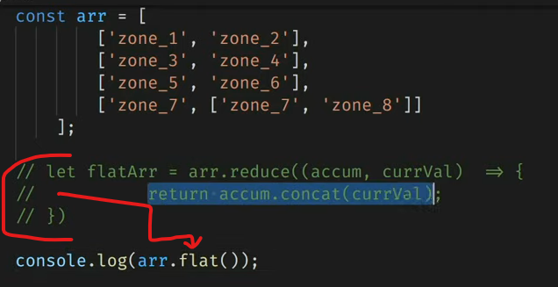

It flats to only 1 level.

Set **Infinity** to have unlimited levels.

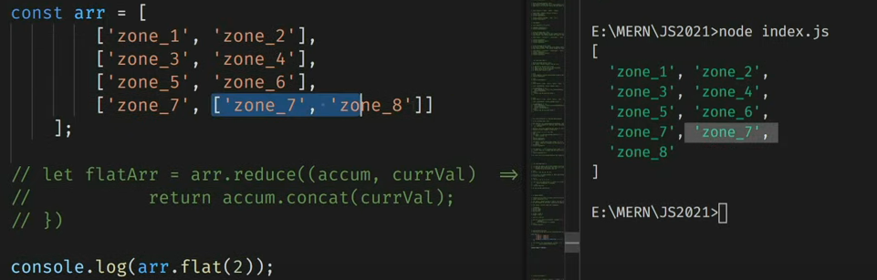

1. Flatmap()
2. formEntries(): convert array to object.

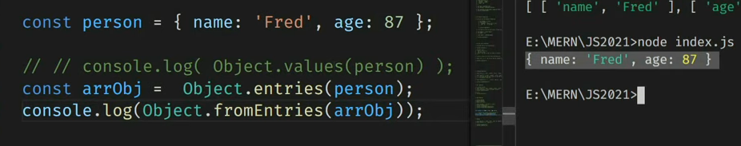

1. trimStart(), trimEnd()

es11:

1.bigint: